

ROS KNIME Logic Docket

1 © 2025 TalenciaGlobal



ROS – Solution Design Docket

Table of Contents
1 ROS – Solution Design Docket 3
2 Introduction to ROS 4
I. ROS Introduction 4
II. Key Goals: 4



ROS – Solution Design Docket

- Team Name : Spreadsheet Spartans
- Scrum Master Name : Hayden

Sl No. | Name | Email
1. | Hayden | hm8692@srmist.edu.in
2. | Aman Deep Singh | as0300@srmist.edu.in
3. | Yash Sinojia | yv4048@srmist.edu.in
4. | Kintali Nikhilesh | kn1752@srmist.edu.in
5. | Akula Sonu | as6626@srmist.edu.in
6. | Kaki Nikhilesh | nk5470@srmist.edu.in
7. | Kusume Hassan | hk0225@srmist.edu.in



Introduction to ROS

ROS Introduction

Restaurant One Solution (ROS) is a comprehensive restaurant management and analytics platform developed to improve operational efficiency, streamline business processes, and increase profitability. It integrates multiple restaurant functions such as cash management, sales tracking, expense monitoring, delivery reconciliation, staff management, and business reporting into a single centralized system.
The ROS project provides an end-to-end data engineering and analytics solution where restaurant data is collected, processed, stored, analyzed, and visualized to support informed business decisions. The system helps restaurant owners and managers monitor key business metrics, identify operational issues, track financial performance, and improve overall business productivity.
This project utilizes a modern data analytics technology stack:
- Microsoft Excel is used for data documentation, data generation, anomaly detection, data cleaning, and initial data preparation.
- SQL Database (MySQL) is used to design and manage a relational database structure for storing and maintaining clean, structured restaurant data.
- KNIME is used for workflow automation, data transformation, validation, reconciliation, and implementation of business workflows.
- Power BI is used to create interactive dashboards, reports, KPI monitoring systems, and business intelligence visualizations.
The ROS solution focuses on transforming raw restaurant transaction data into meaningful business insights through automation, database management, workflow processing, and advanced analytics. By integrating Excel, SQL, KNIME, and Power BI, the project demonstrates a complete data engineering and business intelligence lifecycle from data collection to executive-level reporting.
The primary objective of ROS is to provide restaurant businesses with a data-driven approach to managing operations, improving profitability, reducing errors, enhancing customer satisfaction, and supporting strategic decision-making through real-time analytics and KPI tracking.

Key Goals:

- Customer places order with a restaurant
- Delivery Partners deliver the order to the customer
- CashUp is published to the finance team
- Cashup amount is banked by the designated employee
- Clients purchase subscription with ROS

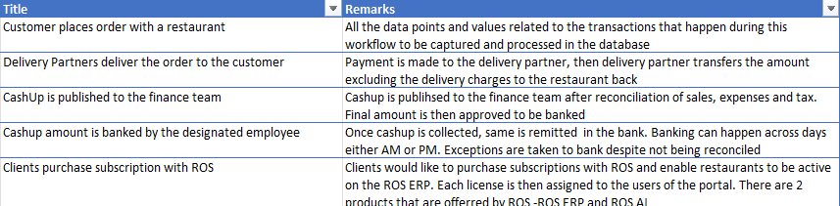


- Customer places order with a restaurant

CSV Reader (orders)
↓
Rule Engine (Validate Order)
↓
Math Formula
↓
Column Filter
↓
CSV Writer / DB Insert

Rule Engine:
$restaurant_id$ IS MISSING => "Invalid"
TRUE => "Valid"

Math Formula:
$food_amount$
+ $drinks_amount$
+ $other_payment$
+ $service_charges$
+ $delivery_charges$
+ $tax_amount$

- Delivery Partners deliver the order to the customer
CSV Reader (orders)
↓
CSV Reader (deliveries)
↓
Joiner (restaurant ID)
↓
Math Formula
↓
Rule Engine
↓
CSV Writer

Math Formula:
$order_amount$ - $api_amount$

Rule Formula:
$match_status$ = 1 => "Matched"
TRUE => "Unmatched"

- CashUp is published to the finance team

CSV Reader (cash_up)
↓
CSV Reader (sales)
↓
Joiner (1)
↓
CSV Reader (expenses)
↓
Joiner (2)
↓
Math Formula
↓
Rule Engine
↓
CSV Writer

Joiner 1:
On => Restaurant ID (cash_up, sales) and cash_up_date (cash_up) = Date (Sales)
Joiner 2:
On Restaurant ID (Joiner 1, Expenses)
Math Formula:
$bod_amount$
+ $sales$
- $expenses$
- $tax$
- $delivery_charges$
Rule Engine:
$match_status$ = 1 => "Reconciled"
TRUE => "Mismatch"

- Cashup amount is banked by the designated employee
CSV Reader (cash_up)
↓
CSV Reader (banking)
↓
Joiner
↓
Math Formula
↓
Rule Engine
↓
Group By
↓
CSV Writer

Math Formula:
$banking_total$ - $banked_total$

Rule Engine:
$reconcile_status$ = "Reconciled" => "Ready For Banking"
$reconcile_status$ = "Partial" => "Exception Banking"
TRUE => "Pending"

Group By:
Banking_time_indicator

- Clients purchase subscription with ROS

CSV Reader (clients)
↓
CSV Reader (subscriptions)
↓
Joiner (1)
↓
CSV Reader (users)
↓
Joiner (2)
↓
GroupBy
↓
CSV Writer

Joiner 1:
subscription_id

Joiner 2:
client_id

Rule Engine:
$subscription_active$ = 1 => "Active"
TRUE => "Inactive"

Group By:
client_name
subscription_name
product_code

